3D Printed Universal Cutting Frame
  - Version 8a
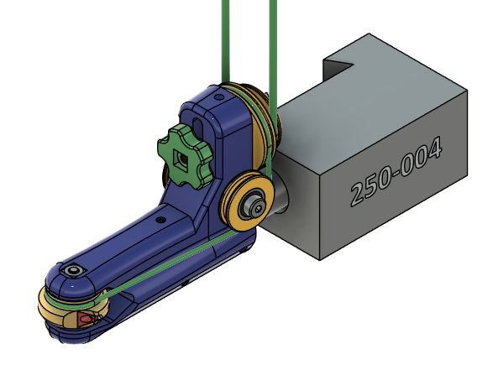

This cutting frame is used on ornamental lathes and rose engines. It is called universal because it can be rotated plus or minus up to 90 degrees from horizontal in the tool holder. Typical all metal universal cutting frames cost between four and six hundred dollars. Using off the shelf hardware and a 3D printer, this can be made for a fraction of that. An overhead drive with 3mm round poly belting is used to drive the cutter. There are several cutter head options for turning CW and CCW with either triangular carbide inserts or round 1/8” carbide engraving bits. Maximum depth of cut with the triangular inserts is 0.050”, but lighter cuts up to 0.020” are recommended. The round engraving bits have a larger maximum depth of cut, but it is still recommended to use lighter cuts.

Main Body

Parts List
Main Body Hardware
Qty | Description
4 | M695ZZ bearing
1 | M5x20 shoulder bolt M4x0.7 thread
2 | M5x10 shoulder bolt M4x0.7 thread
1 | M5x30 shoulder bolt M4x0.7 thread
4 | M4x7x7x3 square nut
1 | M4x12x12x1 square washer
1 | 16x150x1.5 Stainless tube
1 | M5x12x12x1 square washer
1 | 5x0.2 bearing shim
6 | M3x5.5x2.25 square nut
6 | M3x6 set screw
1 | Bearing spacer 5mm X 8mm X 5.5mm *
1 | 2mm X 310mm round poly belt
1 | 3mm round poly belt (Length depends on overhead drive)

Insert Cutter Head Hardware
1 | TDHB07T1202 Triangular Insert
1 | M2.2x6 Torx insert screw
1 | Bearing spacer 5mm X 8mm X 6mm *
2 | M695ZZ bearing
1 | Brass flat stock 4.5mm X 6.5mm X 3mm

Round Cutter Head Hardware
1 | Engraving bit 0.125"
2 | M3x6mm set screw
1 | Bearing spacer 5mm X 8mm X 6mm *
2 | M695ZZ bearing
3 | M5x6mm set screw

3D Print List
Main Body 3D Print (ABS-GF)
1 | UCF_08_MainBody + Supports
2 | Idler Pulley
1 | Double Pulley
1 | Bearing spacer 5mm X 8mm X 5.5mm *
1 | Knob

Insert Cutter Head 3D Print (ABS)
1 | Cutter Head
1 | Bearing spacer 5mm X 8mm X 6mm *
1 | Insert Top Lock. This is optional for insert cutter heads.

Round Cutter Head 3D Print (ABS)
1 | Cutter Head
1 | Bearing spacer 5mm X 8mm X 6mm *
1 | Sharpening jig 60 degrees
1 | Sharpening jig 90 degrees
1 | Sharpening jig 120 degrees

Tools
Metric Allen wrench set
M3 Tap (Round engraving bit cutter head)
M2.2 Tap (Insert nut cutter head)
1.75mm drill or #51 (0.067") for M2.2 thread
.125" drill (Round engraving bit cutter head)

*Bearing spacers can be 3D printed, but brass tubing is better. Brass tubing with 5mm ID and 1.5mm walls is readily available.

Assembly

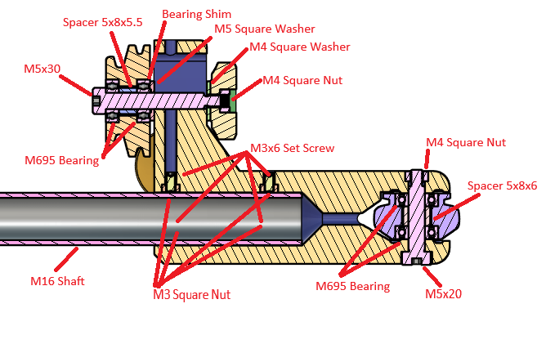
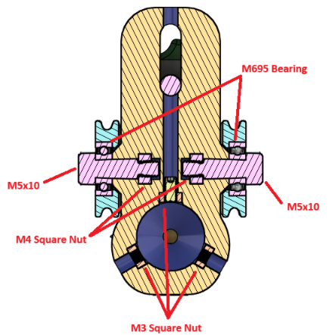

Shaft
- Insert M3 square nuts into the shaft opening. Note: Medium CA glue the inner three nuts to a short rod and use a long M3 screw to pull the nuts into their holes.
- Insert the 16mm diameter shaft and secure with six M3 set screws.
- Note: Shaft must be installed before the pulleys.

Idler Pulleys
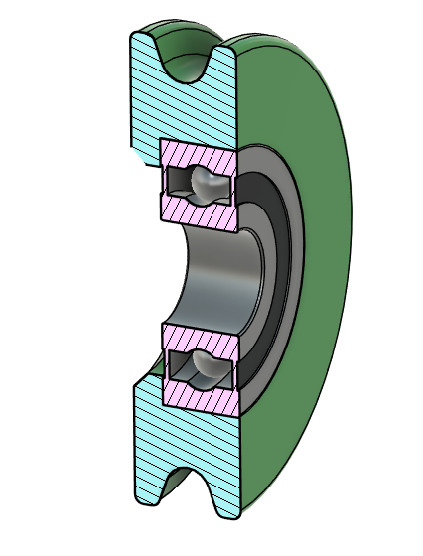
- Press the M695ZZ bearings into the idler pulleys.
- Press M4 square nuts into the openings at the back of the main arm.
- Attach the idler pulleys to the main arm using M5x10 shoulder bolts. Note: Metric shoulder bolts come with different thread sizes, so ensure yours have M4 threads.

Drive pulley
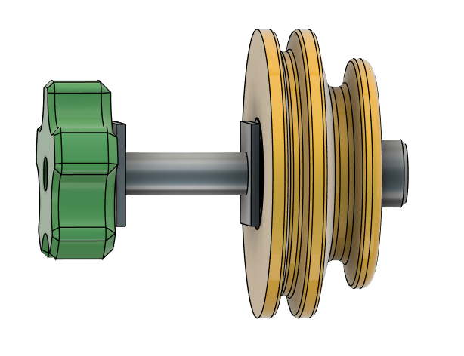
- Install the M695ZZ bearings and double pulley bearing spacer into the double pulley.
- Press the M4 heat set insert into the knob.
- Install the pulley using an M5x25 shoulder bolt, bearing shim, and washer. Use a washer and the knob to secure it. Note: The larger diameter pulley is next to the main arm.
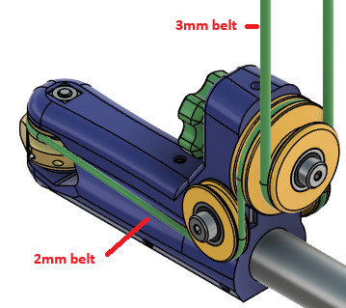

Cutter heads
Three cutter head styles are included. The 1/8” engraving bit head is the simplest to assemble. The plain insert head requires careful tapping the M2.2 hole, while the brass nut insert head requires manufacturing the nut out of brass stock. Each style of the insert cutter heads come in clockwise (CW) and counterclockwise (CCW) versions.
Common assembly steps for all cutter heads:
- Press one M695 bearing into the head.
- Add the cutter head spacer 5mm X 8mm X 6mm.
- Press the second bearing into the head.
- Slide the cutter head into position and secure with the M5x20 shoulder bolt and M4 square nut.

Insert head (Plain)
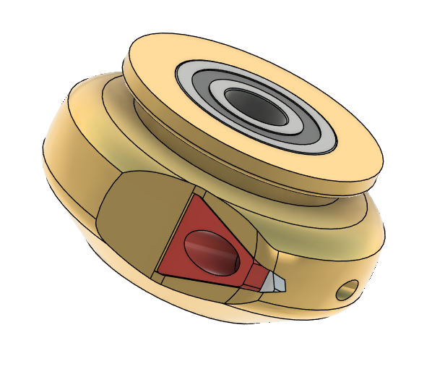
CW cutter head is shown
- Carefully tap the insert hole with 2.2mm tap.
- Attach the insert. It will be a tight fit. Do not over tighten the locking screw.
- Optional: Insert Top Lock can be installed using acetone to secure it. Using this may limit use to only one tip. Reprint the cutter head body to use the other tips.

Insert head (Brass Nut)
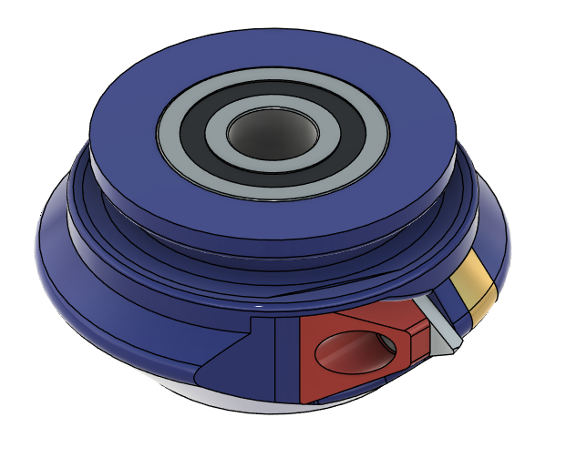

Insert Nut
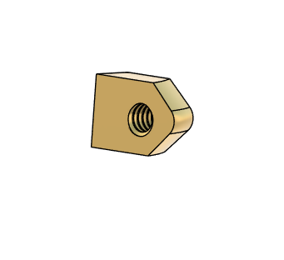
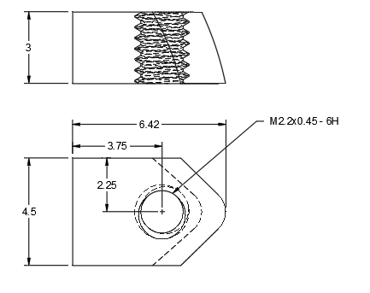
- Insert nut is the same for both CW and CCW versions.
- Drill and tap brass nut. Insert into opening. Final profile can be done quickly with a file.
- Attach insert with M2.2x6 torx screw.
- Optional: Insert Top Lock can be installed using acetone to secure it. Using this may limit use to only one tip. Other cutter heads can be printed to use the other tips.

1/8” engraving bit head
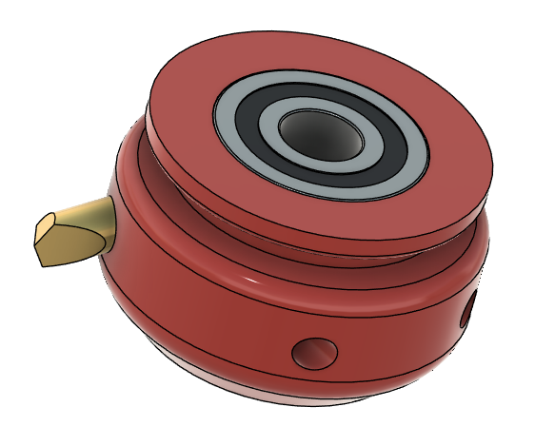
- Tap the locking screw holes with M3 tap.
- Install the engraving bit. The hole may need to be reamed or drilled first. The bit may be set for either CW or CCW rotation.
- Install the locking M3 set screws. Do not over tighten.

Belts

- Belts must be cut to length and welded.
- Attach the 2mm round poly belt around the drive pulley, under the idler pulleys and around the cutter head.
- Belt tension is adjusted by moving the drive pulley up or down, then locked in place with the knob.
- The 3mm round poly belt runs between the drive pulley and the overhead drive. CCW rotation is achieved by twisting the belt 180 degrees.

Engraving bit sharpening jigs
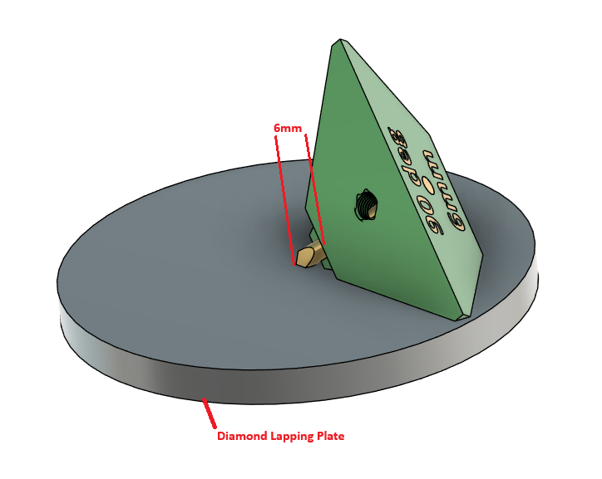
Jigs for 60, 90, and 120 degrees included angles are included. Secure the engraving bit in the jig using an M5x6mm set screw. Use diamond lapping plates to create the profiles on three sides. It is recommended to use at least 3000 grit for the final polishing. Even finer grits may give even better cut surfaces. Set the distance between the cutter tip and the ledge on the jig to the distance printed on the bottom of the jig, either 6mm or 10mm.

3D printer slicer settings
- Walls: 8.
- Infill: 40% Cubic.
- Brim: 12mm (Depends on how well your build plate works for small parts).
- Filament: ABS-GF for the main body and pulleys. ABS for the cutterheads and sharpening jigs.

Main Body and pulleys
- .20 layer height
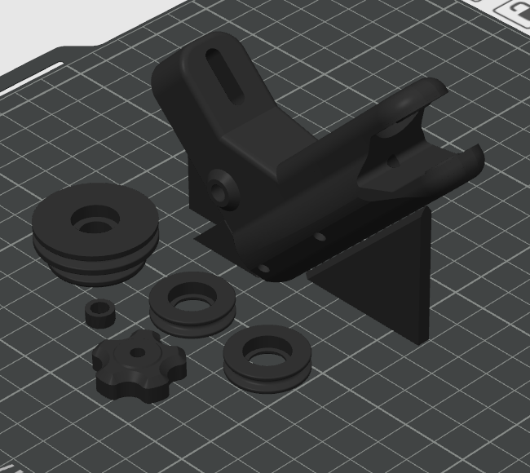

Round Engraving Bit Cutter Head
- .12 layer height.
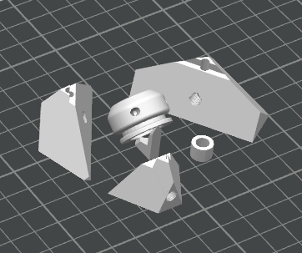

Triangular Insert Cutter Head Plain
- .12 layer height.
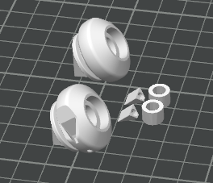

Triangular Insert Cutter Head Brass Nut
- .12 layer height.
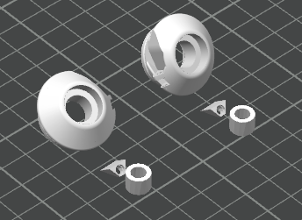

Notes:
The pulleys and cutterhead should move freely.
The bearings in the pulleys may get hot to the touch when first running. This seems to diminish over time.
Do not take heavy cuts.
Models for clockwise and counterclockwise insert cutterheads are included as well as a model for 1/8” bits.
Sharpening jigs for 60 degree and 120 degree engraving bits are included.

